INTRA-DISCIPLINARY PROJECT-I REPORT

**“SPEECH TO TEXT CONVERSION”**

**Submitted**

by

|  |  |
| --- | --- |
| B.Deepthi  201FA04140 | G.Durga Susmitha  201FA04147 |
| V.Lavanya  201FA04172 | |

Under the guidance of

***Mr.K Venkata Subramanyam,Asst.Professor***



**DEPARTMENT OF COMPUTER SCIENCE & ENGINEERING**

**VIGNAN'S FOUNDATION FOR SCIENCE, TECHNOLOGY AND RESEARCH Deemed to be UNIVERSITY**

**Vadlamudi, Guntur.**

**VIGNAN’S FOUNDATION FOR SCIENCE, TECHNOLOGY AND RESEARCH**

**Deemed to be UNIVERSITY**

VADLAMUDI, GUNTUR DIST, ANDHRA PRADESH, INDIA, PIN-522 213



**CERTIFICATE**

This is to certify that the Intra-Disciplinary Project-I entitled **“Speech To Text Conversion”** that is being submitted by **B.Deepthi (201FA04140), G.Durga Susmitha (201FA04147), V.Lavanya(201FA04172)** for partial fulfilment of Intra-Disciplinary Project-I is a bonafide work carried out under the supervision of ***Mr.K Venkata Subramanyam,Asst.Professor*** from Department of Computer Science & Engineering.

Mr.K.venkata Subramanyam K V. Krishna Kishore

Asst.professor,Dept.of CSE HOD,CSE

Internal Examiner External Examiner

**VIGNAN’S FOUNDATION FOR SCIENCE, TECHNOLOGY AND RESEARCH**

**Deemed to be UNIVERSITY**

VADLAMUDI, GUNTUR DIST, ANDHRA PRADESH, INDIA, PIN-522 213



**DECLARATION**

We hereby declare that the Intra-Disciplinary Project-I entitled **“Speech To Text Conversion”** is being submitted by **B.Deepthi (201FA04140), G.Durga Susmitha (201FA04147), V.Lavanya(201FA04172)** in partial fulfilment of Intra-Disciplinary Projects-I course work. This is our original work, and this project has not formed the basis for the award of any degree. We have worked under the supervision of ***Mr.K.Venkata Subramanyam*** from Department of Computer Science & Engineering.

By

201FA04140

201FA04147

201FA04172

Date:

TABLE OF CONTENTS

1. Introduction..........................................................................1-2
2. Related work.........................................................................3
3. Proposed work......................................................................4
4. Implementation.....................................................................5-6
5. Results...................................................................................7-8
6. Conclusion.............................................................................9
7. Future scope...........................................................................10
8. References..............................................................................11

**INTRODUCTION**

* Speech to text conversation is the process of converting spoken words into written texts.
* Nearly 20% people of the world are suffering from various disabilities; many of them are blind or unable to use their hands effectively. They can share information with people by operating computer through voice input.
* Speech recognition technology is one from the fast growing engineering technologies.
  1. **Problem Statement:**
* Unable to type every word while listening.

Eg:- While in a online class, it is not possible to write every word.

* Unable to understand audio files.

Eg:-In any academic event, information is usually addressed through audio channels so that students with learning or physical disabilities, foreign students, and other at risk populations are challenged to understand the content.

* In relation to online learning literature, problem is the poor audio quality.

Eg:- Due to restricted internet bandwidth availability and traffic congestion, students are not able to understand concepts clearly.

* So we are solving this problem by our project “Speech into Text” that is a complete student/teacher oriented platform to help in taking notes and understanding

**1.2 Project Overview/Specifications:**

* The main goal of this Python based project is to build a recommendation engine that converts speech to text.
* A conversion algorithm will also look for mic and recorded files*.*
* A conversion system is a platform that serves up large audio files, and different languages.

**1.3 Hardware Requirements:**

|  |  |
| --- | --- |
| **Name of component** | **Specification** |
| Processor | Pentium-IV |
| RAM | 4Gb & More |
| Hard-Disk | 2gb & More |

**1.4 Software Requirements:**

* Chrome
* Google
* Idle 3.10
* Cloud
* Speech Recognition
* Tkinter
* Pyaudio

**RELATED WORK**

# This study aims to review previous STR technology relevant literature and how it can enhance learning. STR technology was mostly used to assist specific groups of students (i.e., students with learning or physical disabilities or foreign students) in order to guarantee them the equal access to learning.

* Now-a-days STR technology is adopted to assist not only students with special needs but also general population of students for more educational purposes, such as enhancing students’ understanding of a presented learning content during and after academic activities as well as offering students guidance to accomplish reflective writing and homework.
* Furthermore, due to recent improvement of STR technology, particularly its accuracy rate, the technology is also adopted to support collaborative learning activities with multiple participants speaking simultaneously, such as group discussions or students’ oral presentations.
* Therefore,this study particularly summarized STR development history and its usage by specific group of users

**PROPOSED WORK**

* This study demonstrates how effective STR technology can be to enhance learning for different groups of users, such as students with learning or physical disabilities, foreign students, online students, and students who study in physical environment.
* This study further highlights findings on STR technology and proposes several suggestions for future research.
* This study looks into how STR technology has been used in education over the past fifteen years by reviewing relevant research.

**IMPLEMENTATION**

**4.1 Problem Formulation:**

Speech Recognition is an important feature in several applications used such as home automation, artificial intelligence, etc. This article aims to provide an introduction on how to make use of the SpeechRecognition and pyttsx3 library of Python.

**Installation required:**

* + - **Python Speech Recognition module** : PyAudio
    - **Python pyttsx3 module**: Speech Input Using a Microphone and Translation of Speech to Text
    - **Allow Adjusting for Ambient Noise:** Since the surrounding noise varies, we must allow the program a second or too to adjust the energy threshold of recording so it is adjusted according to the external noise level.
    - **Speech to text translation:** This is done with the help of Google Speech Recognition. This requires an active internet connection to work. However, there are certain offline Recognition systems such as PocketSphinx, but have a very rigorous installation process that requires several dependencies. Google Speech Recognition is one of the easiest to use.

**Translation of Speech to Text:**

* + - First, we need to import the library and then initialize it using init() function. This function may take 2 arguments.

**4.2 Research Objectives:**

The proposed work is aimed to carry out work leading to the development of an approach for Speech to text Conversion.

**The proposed aim will be achieved by dividing the work into following objectives:**

* Downloading Files
* Audio files converted to text
* Large files into text
  + Speech to Text

**4.3 Methodology:**

The following methodology will be followed to achieve the objectives defined for proposed research work:

* **Installing Python Libraries:** Install library like tkinter, speech recognition, pyaudio.
* **Importing Speech Recognition:** Importing google speech module.
* **Converting wav files into Text:** Selecting and extracting text

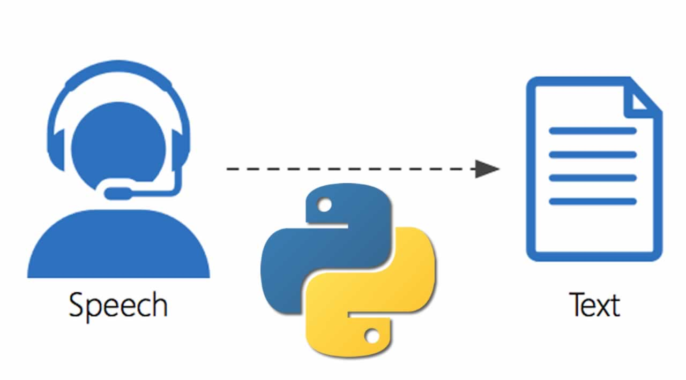

**RESULT**

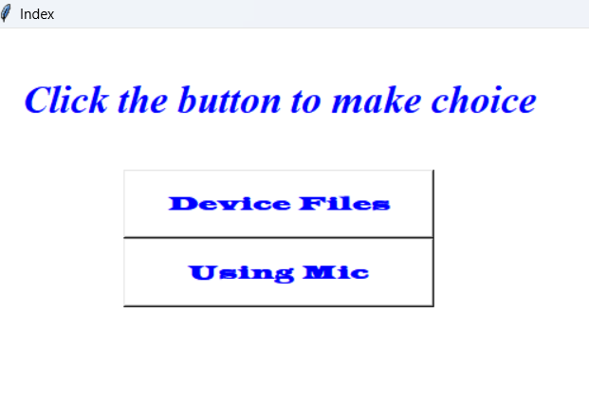

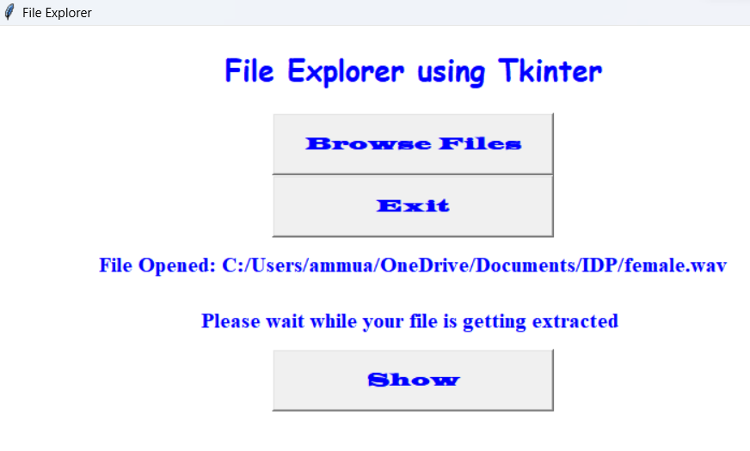

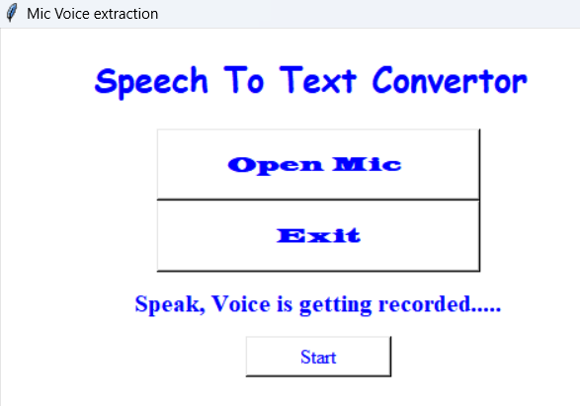

**CONCLUSION**

* Although speech-to-text conversion machines aim at providing benefits for the deaf or people who can't speak, it is difficult to review, retrieve and reuse speech transcripts.
* So, when the speech to text conversion module is combined with the summarization, the application further increase in educational fields as well.
* This chapter discussed the need for speech summarization, various issues in the summarization of a spoken document, supervised, and unsupervised summarization algorithms

**FUTURE SCOPE**

* Accuracy will become better and better
* Dictation speech recognition will gradually become accepted
* Greater use will be made of "intelligent systems" which will attempt to guess what the speaker intended to say, rather than what was actually said, as people often misspeak and make unintentional mistakes.
* Microphone and sound systems will be designed to adapt more quickly to changing background noise levels,different environments, with better recognition of extraneous ma

**REFERENCES**

* J. F. Islam, M. Mondal, and C. K. Roy, “Bug Replication in Code Clones: An Empirical Study,” in 2016 IEEE 23rd International Conference on Software Analysis, Evolution, and Reengineering (SANER), 2016, pp. 68–78.
* C. K. Roy, M. F. Zibran, and R. Koschke, “The vision of software clone management: Past, present, and future (Keynote paper),” in 2014 Software Evolution Week - IEEE Conference on Software Maintenance, Reengineering, and Reverse Engineering (CSMR-WCRE), 2014, pp. 18–33.
* https://www.britannica.com/technology/speech-recognition
* https://support.microsoft.com/en-us/windows/dictate-text-using-speech-recognition-854ef1de-7041-9482-d755-8fdf2126ef27
* https://cloud.google.com/speech-to-text